**Topic : Descent work and Economic Growth**

|  |  |
| --- | --- |
| **Student Registration Number** | **Name** |
| **IT20642914** | **Gamage B.G.A.C** |
| **IT20641092** | **W.S.S Wijesinha** |
| **IT20637064** | **R.M.C Anuththara** |
| **IT20639662** | **Navodi P.T** |

**Group ID : SEJ006**

Goal – Descent work and Economic Growth

Problem - There are many people who is unemployed and looking job opportunities for their qualifications and many people looking for the fundamental knowledge for the self employment.

There are many businessmen who are looking people to employment.

Solution – Through our application we allow many people to find the job opportunities, apply to jobs ,find employees for their job rolls ,and consult people and give fundamental knowladge to build their own business.

**Persona**

**1)IT20642914**

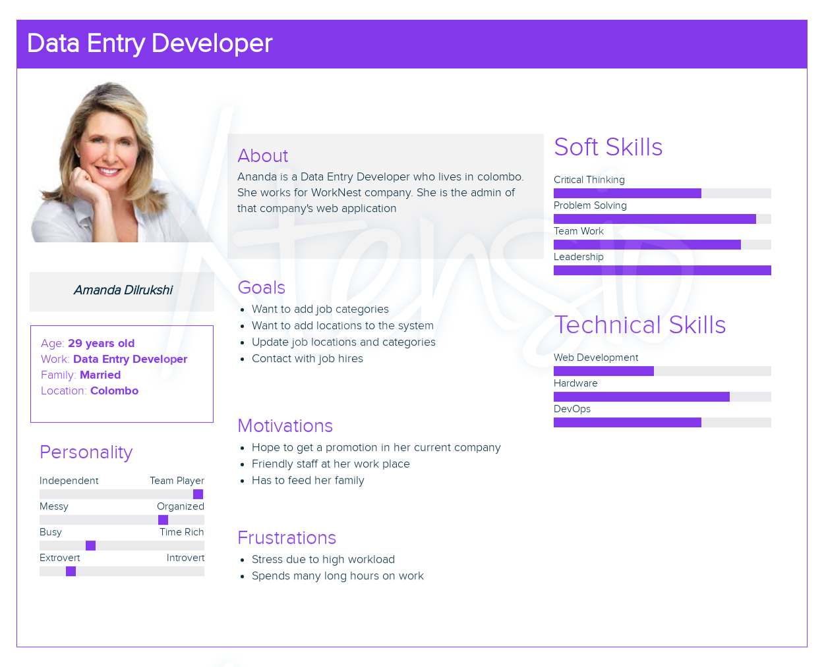

**User Story**

As a admin,

I want to add categories in to the system,

So that user will be able to search jobs from categorized list.

**User flow**

**2)IT20641092**

**User Story**

As a registered job seeker,

I want to find suitable job information and apply for jobs

So that I can find a suitable job for my qualifications.

**User Flow**

**3)IT20639662**

**User Story**

As a registered job hiring man,

I want to add job post to the system,

So that job seeker will be able to apply for the job.

**User Flow**

**4)IT20637064**

As a consulter,

I want to inform to people about the available self-employment opportunities

So that I can contributes to economic growth.

**Service Blue Print**

